Legal notices
The information in this document is subject to change without notice.

Envox d.o.o. makes no warranty of any kind with regard to this manual, including, but not limited to, the implied warranties of merchantability and fitness for a particular purpose.
Envox d.o.o. shall not be held liable for errors contained herein or direct, indirect, special, incidental or consequential damages in connection with the furnishing, performance, or use of this material.

This document is released under open license FDL v1.3 from GNU.org. Therefore you are entitled to freely copy and redistribute it, with or without modifying it, either commercially or non-commercially. For additional details please consult the content of the license.

Contact Us
If you have any problem or requirement when using EEZ products or this manual, please contact Envox:
E-mail: support@envox.hr
Website: www.envox.hr

Acknowledgments
Icons made by pixel-perfect and freepik from flaticon.com
Document created in OpenOffice / LibreOffice
Proofreading by <feel free to add your name/alias/whatever>

Who Should Use This Manual
This manual is designed for users who are familiar with basic electrical theory, especially as it applies to the operation of power supplies. This includes understanding of Constant Voltage and Constant Current operating modes and the control of input and output power, as well as the observance of safe techniques while making supply or pin connections and any changes in settings.

Safety Requirements
The EEZ BB3 is designated for use in laboratory, residential, business, commercial and small business areas.

Use an EEZ BB3 only for its designated purpose. Observe the safety and usage instructions documented in the user manual, and operating conditions and performance limits stated in the data sheet.

The product documentation helps you to use the EEZ BB3 safely and efficiently.
Keep the product documentation in a safe place and pass it on to the subsequent users.

Please review the following safety precautions carefully before putting the EEZ BB3 into operation so as to avoid any personal injuries or damage to the EEZ BB3 or any device connected to it. To prevent potential hazards, please use the EEZ BB3 only specified by this manual.
- Use only the undamaged power cord designed for the EEZ BB3 and authorized by local country.
- The EEZ BB3 is grounded through the Protective Earth (PE) lead of the power cord. To avoid electric shock, it is essential to connect the earth terminal of power cord to the Protective Earth terminal before any inputs or outputs.
- To avoid fire or shock hazard, observe all ratings and markers on the EEZ BB3 and check your manual for more information about ratings before connecting.
- Do not operate the EEZ BB3 with covers or panels removed.
- Make sure that fuses specified for installed modules and AC line voltage are installed.
- If you suspect that the EEZ BB3 is damaged or not operating correctly (e.g. the power up self-test failed or any function does not work as expected) contact Envox support.
- Ensure adequate clearance to the rear panel cooling fan air intake. Inadequate ventilation may result in high temperature and premature or multiple triggers of the OTP (over-temperature protection).
- In order to avoid short circuit or electric shock, please do not operate the EEZ BB3 in a humid environment.
- In order to avoid damaging the device or personal injury, do not expose the device to flammable gasses.
- Keep EEZ BB3 surfaces clean and dry to avoid the influence of dust and/or moisture in the operating environment.
- Operate in an electrostatic discharge protective area environment to avoid damage induced by static discharge.

Risk of electric shock
The casing and all chassis parts are connected to a Protective Earth (PE) conductor. Disconnection of the earthed protective connection inside or outside the EEZ BB3 is prohibited.

Risk of electric shock due to exceeding low voltage protection
Output coupling of two power module in series provides voltage as high as 80 V. In this case, any contact with live components is life threatening. Only qualified and trained personnel should operate the EEZ BB3 and any connected loads.

Care and cleaning
Do not store or leave the instrument where instrument will be exposed to direct sunlight for extended periods of time. That could result in permanent damage of the TFT display.

It is recommended to clean the EEZ BB3 regularly according to its operating conditions. To clean the exterior surface, perform the following steps:
- Disconnect the EEZ BB3 from AC line power
- Use a lint-free cloth (with a mild detergent or water) to clean the loose dust on the outside of the EEZ BB3. Take extra care when cleaning the TFT display to avoid scratching it.

WARNING: To avoid injury resulting from short circuit, make sure the EEZ BB3 is completely dry before connecting it to AC line power.

Environmental Considerations
The following symbol indicates that this product complies with the applicable European Union requirements according to Directives 2012/19/EU on waste electrical and electronic equipment (WEEE) and batteries.


Product End-of-Life Handling
The EEZ BB3 may contain substances that could be harmful to the environment or human health. In order to avoid release of such substances into the environment and harm to human health, we encourage you to recycle this product in an appropriate system that will ensure that most of the materials are reused or recycled appropriately. Please contact your local authorities for disposal or recycling information.

Key features
The EEZ BB3 is a modular DC power supply with multiple isolated channels, combined power output up to 465 W, maximum voltage output ranging from 20 to 80 V and maximum current output of up to 10 A. The graphical user interface features a large color TFT touch-screen display combined with an incremental encoder providing a clear, responsive and easy to operate interface. Outstanding key features of the EEZ BB3 are:

General
- Modular design based on EEZ DIB v1.0 specification enabling multiple configurations and future-proof upgrading
- Three module slots for installation of different power modules in any combination
- Minimized wire harness and easily accessible modules simplify assembly, upgrade and maintenance
- High performance 32-bit ARM Cortex M7 master MCU
- Power output coupling without external wiring thanks to built in power relays that provides coupling in series, parallel or split rails for two modules and common ground for all three modules
- Down-programmer with high current capability (DCP405 module only)
- Full range auto-switch AC input (115 / 230 Vac)
- Low noise Ø80 mm cooling fan with speed algorithm based on multiple temperature sensors and output current readings
- Compact size: 290 (W) x 123 (H) x 240 (D) mm
- Free and open source software and open source hardware design

User interface and programming
- Large color 4.3” (470 x 272) TFT touch-screen display as human machine interface (HMI) for fast and simple navigation through all available options and each channel's info minimize/maximize feature
- Multiple color themes
- Encoder with switch plus user-defined switch complement the TFT touch-screen for even faster and easier navigation
- Ten user-defined profiles with power-up recall control
- Calibration wizard
- High programming and readback resolution for applications with the highest demands
- Independent real-time voltage, current and power measurement of all installed channels
- Four display modes: numerical, horizontal bar, vertical bar and YT-view
- Two YT-view modes (cursor or data scroll) and with high refresh rate (down to 10 mS)
- Output Enable (OE) synchronization and sequencing with programmable delays
- Arbitrary waveform generation function with user friendly GUI for both voltage and current
- Multi-channel tracking function
- USB DFU firmware upgrade for master MCU and slave MCUs on peripheral boards
- Trigger system with various inputs (manual, software, digital input, etc.)
- Comprehensive SCPI support (300+ commands)
- Cross-platform (Linux, OS X, Windows) EEZ Studio comes with intuitive HMI editor and provides centralized control, programming, data acquisition and analysis of multiple EEZ BB3 and 3rd party SCPI-enabled instruments. Free to download

Connectivity
- Remote control via Ethernet or USB interface
- Removable Micro SD card
- USB 2.0 OTG
- RTC with battery backup and NTP synchronization (via Ethernet)
- Digital control lines (2 x input + 2 x output, buffered and protected)

Protections and controls
- AC soft-start (inrush current limiter) and standby control
- AC input protection (MOV, VAR, SAR)
- Multiple channel- and system-wide protections against over-voltage, over-current (with electronic fuse function), over-power and over-temperature with adjustable trip delay
- Remote sense reverse polarity protection (DCP405 module only)
- Fast over-voltage protection with triac crowbar (DCP405 module only)
- User interface lock function with password protections

For a detailed specification, refer to the data sheet.

Operation Environment
- Location: Indoor, no direct sunlight, dust free, almost non-conductive pollution (note below)
- Relative Humidity: < 80 %
- Altitude: < 2000 m
- Temperature: 0°C to 40 °C
(Pollution Degree) EN 61010-1:2001 specifies the pollution degrees and their requirements as follows. The EEZ BB3 falls under degree 2. Pollution refers to “addition of foreign matter, solid, liquid, or gaseous (ionized gases), that may produce a reduction of dielectric strength or surface resistivity”.
- Pollution degree 1: No pollution or only dry, non-conductive pollution occurs. The pollution has no influence.
- Pollution degree 2: Normally only non-conductive pollution occurs. Occasionally, however, a temporary conductivity caused by condensation must be expected.
- Pollution degree 3: Conductive pollution occurs, or dry, non-conductive pollution occurs which becomes conductive due to condensation which is expected. In such conditions, equipment is normally protected against exposure to direct sunlight, precipitation, and full wind pressure, but neither temperature nor humidity is controlled.

Storage environment
- Location: Indoor
- Relative Humidity: < 70 %
- Temperature: −10 °C to 70 °C

Unpacking and Checking the EEZ BB3
To remove the EEZ BB3 from its packaging and check the equipment for completeness, proceed as follows:
- Check the package for damage
- Carefully unpack the EEZ BB3 and the accessories
- Check the package contents for completeness using the Delivery list and package contents
- Check the equipment for any visible shipping-related damage or other mechanical problems, e.g. loose parts inside
If there is damage or anything missing, contact the supplier and the carrier who delivered the EEZ BB3. Do not operate the EEZ BB3 in this case.

Retain the original packing material. If the EEZ BB3 needs to be transported or shipped later, you can use the material to protect the exposed and fragile elements on the front panel.

The EEZ BB3 must be stored in dry, closed, indoor premises. If the EEZ BB3 was transported under extreme temperatures, it is recommended that you allow a minimum of two hours to reach the appropriate temperature before operating the EEZ BB3.

Delivery List
The EEZ BB3 comes with the following components:
- EEZ BB3 preloaded with selected modules
- Two AC mains fuses for 115 V or 230 V operation
- AC mains cable for the selected region
- Read me first leaflet with links to online documentation
- Set of DC power cables, clip-on probes and crocodile clips (optional)

Placing the EEZ BB3
If the EEZ BB3 is operated on a bench top, the surface must be flat. You can place the EEZ BB3 horizontally, or in a slope position by unfolding the front feet.

The feet can fold in if they are not folded out completely or if the EEZ BB3 is shifted. Collapsing feet can cause injury or damage the EEZ BB3.
- Fold the feet completely in or out to ensure stability of the EEZ BB3.
- Never shift the EEZ BB3 when the feet are folded out.
- When the feet are folded out, do not work under the EEZ BB3 and avoid placing anything underneath.

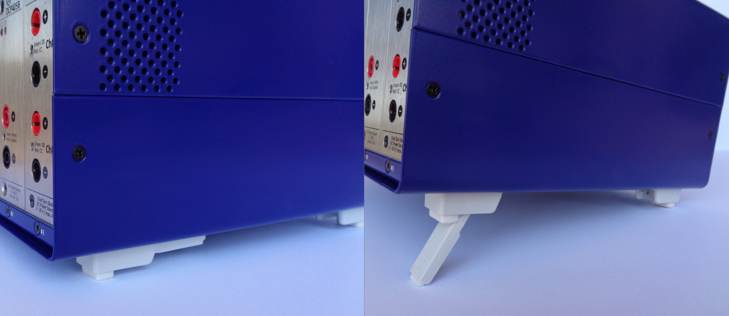Fig. 1: Adjustable front feet
The front feet in folded out position can break if they are overloaded. The overall load on the folded out feet must not exceed 50 N. If the front feet are folded in, it is possible to stack the EEZ BB3 with more instruments securely.

Starting the EEZ BB3
The EEZ BB3 is equipped with an AC power supply connector, (IEC C14 type) which can be used with different AC power voltages in wide range without need to adjust manually input voltage or frequency.

IMPORTANT: The EEZ BB3 must only be connected to an outlet that has a functional ground contact
- Check the AC line voltage.
- Check the fuse type and if necessary replace the fuse type suitable for the line voltage.
- Connect the EEZ BB3 to the AC mains using the supplied power cable.

Replacing the fuses
The EEZ BB3 has main power fuses, which are located on the rear panel of the unit. Handling the fuses while power is on can lead to electric shock. Therefore, before opening the fuse holder (see Fig. 2), make sure that the EEZ BB3 is disconnected from AC power.

To replace the fuses the EEZ BB3 has an externally accessible fuse holder combined with the IEC socket.
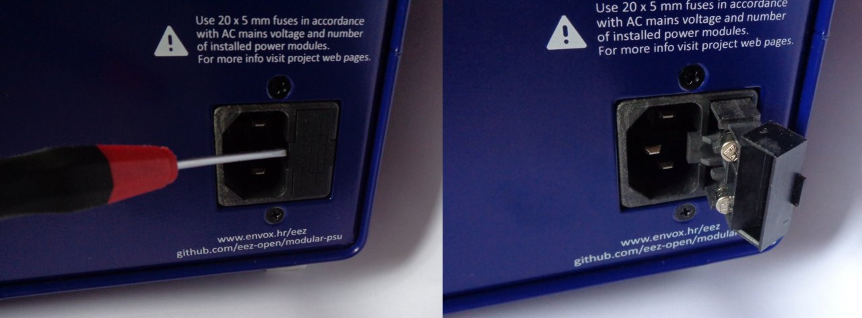Fig. 2: Opening the fuse holder

The nominal current of the fuse depends on the line voltage and number of installed power modules. Select the fuses according to the voltage of the AC line, as specified in Table 1. Fuse size is 20 x 5 mm of time-lag type and has to be rated for the selected AC line voltage.

No. of power modules | 1 | 2 | 3
115 V | 2 x 3.15 A | 2 x 6 A | 2 x 8 A
230 V | 2 x 2 A | 2 x 4 A | 2 x 6 A
Table 1: Fuses selection

Battery replacement
The CR2025 coin cell battery is used as a power backup for the RTC. It uses a non-rechargeable lithium battery that will need to be replaced when its voltage drops to approximately 90 % of its rated value. The current battery value can be viewed on the System information page.

To access the EEZ BB3 interior, First, turn off the EEZ BB3 and unplug the power cord from the back, then remove the top cover, which is secured by four screws (two on each side).

Fig. 3 shows the procedure required to install or replace an existing battery.

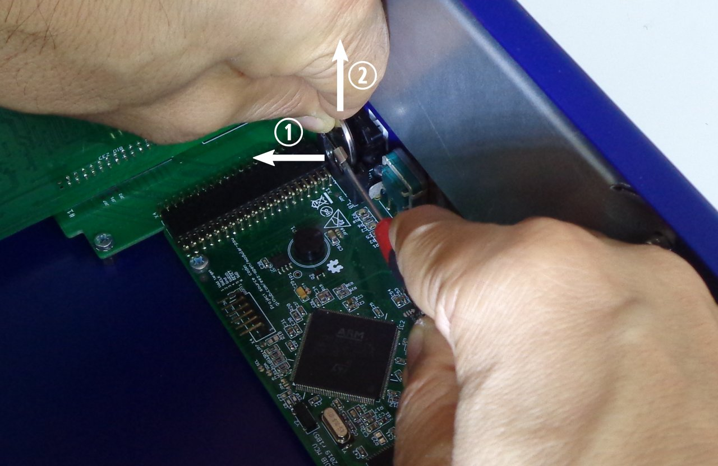Fig. 3: Coin cell battery removal

❑ | Using a screwdriver or finger, pull the battery holder latch in the direction of the arrow.
⬥ | While holding the latch, remove the battery from the holder.

Do not use metal pliers instead of your fingers to insert or remove the battery as it may cause a short circuit. If you cannot reach the battery with your fingers, use a plastic tweezers instead.

Do not expose the battery to high temperature or fire. Keep it out of the reach of children. Improper change of a battery may cause damage, fire or explosion.

Micro SD card (non-volatile memory)
The EEZ BB3 uses a micro SD card as a non-volatile memory. Due to its small size, extra care will be required when inserting and pulling out to prevent damage to the card or socket.

Attention should also be paid that the card is inserted correctly into the socket otherwise it could fall inside the enclosure. Therefore, it is recommended that the EEZ BB3 be completely switched off (not in standby mode!) when the card is inserted.

Fig. 4 shows how the card should be positioned when inserted: its connectors should be facing up (i.e. must be visible).

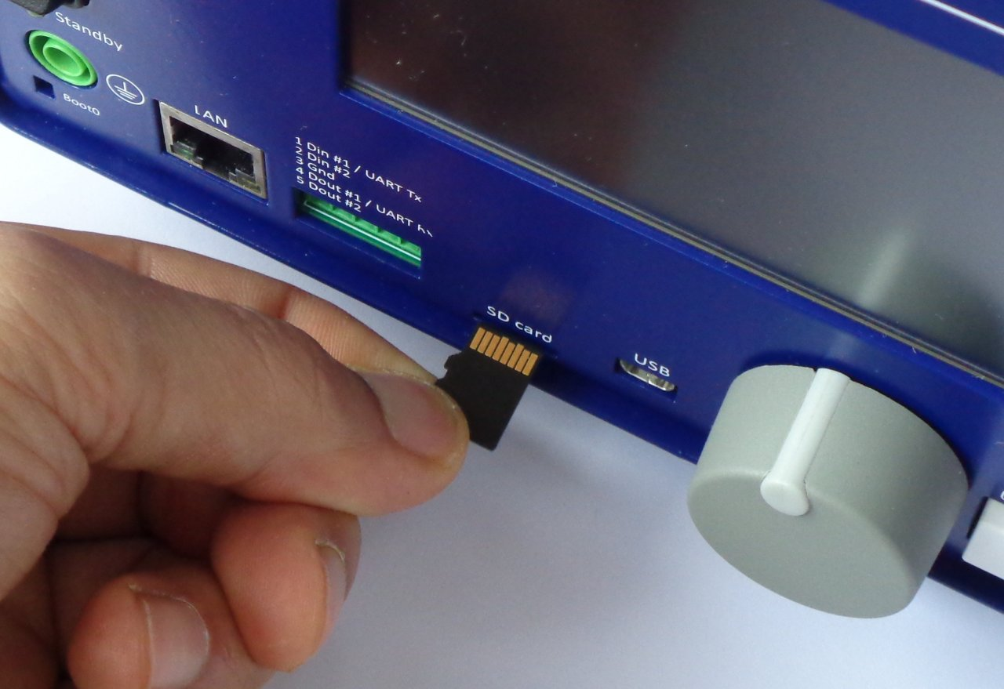Fig. 4: Micro SD card insertion

